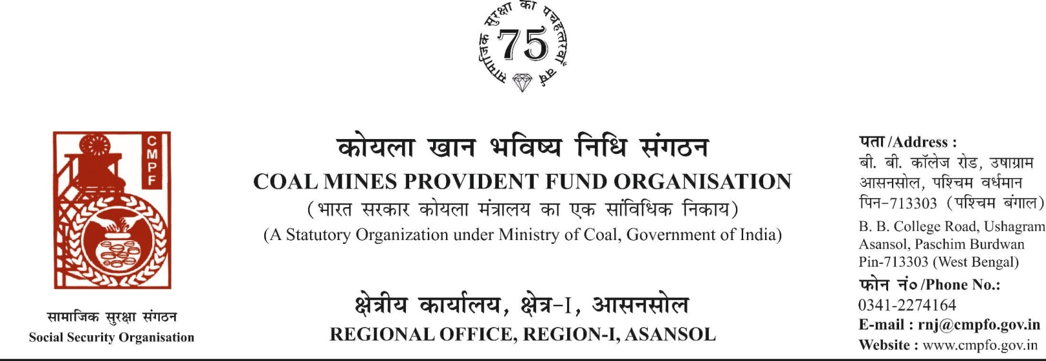

CPF/118/MISC/L.C. IN-OUT/REQ/Voll-2/R-I/ASN Date-12/08/2025
To,
The Regional Commissioner
C.M.P.F , Singrauli
PO-Jayant Dist-Singrauli-486890
Madhya Pradesh

Sub- Sub- Inter-Regional Transfer of Ledger Card
Ref. : GM/SBA/Pers/59/2024/994 Dated. : 15/05/2024
Sir,
In view of the revised procedure prescribed in procedure office order No-230 Dated-12/02/1973 of CMPF Commissioner, Dhanbad, I am to state that the ledger card of the following member is forwarded to your office as he is working under jurisdiction of your region.
It is ensured that the posting in the ledger card are dully completed for the periods for which the member was contributing in this region.
SL. No | Name of the member | CMPF A/C No | Name of the colly where member worked in this region | Name o the colliery where member working in your region
1 | Sri Rajesh kumar Mishra | SING/03/3776 | SonepurBazari Area (RNJ/41) | Amlohri Area, NCL
2 | Sri vimlesh Kumar Kaushal | SING/06/2169 | Sonepur Bazari  Area (RNJ/41) | Kakri Project, NCL

Encl- As above
Yours faithfully

Assistant Commissioner

